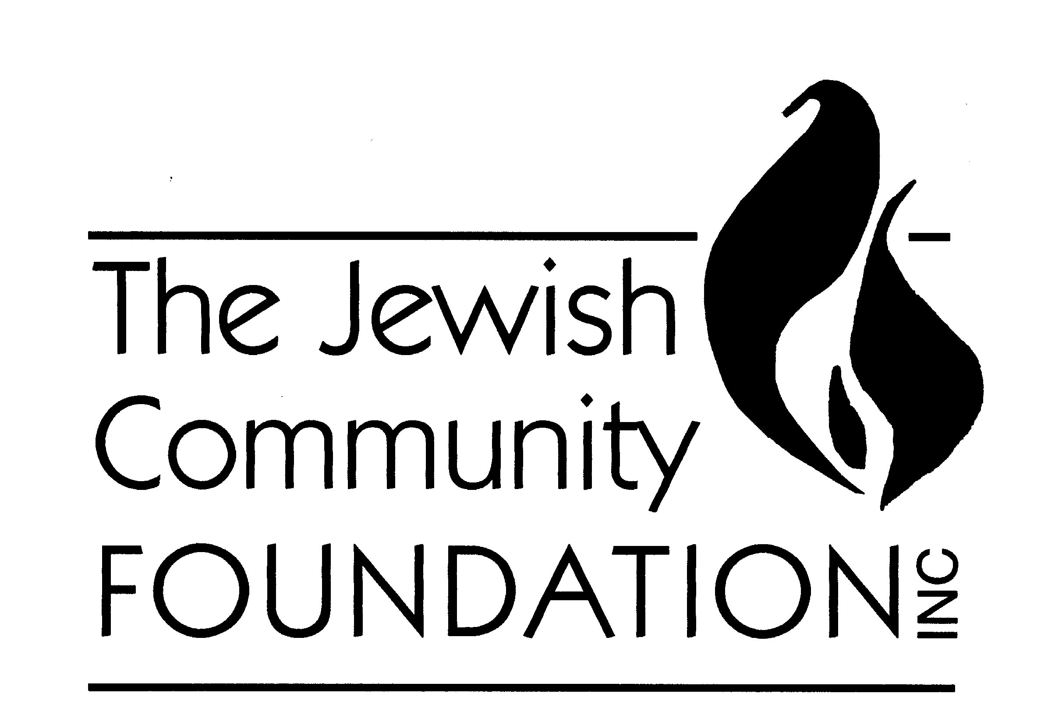

JCF Scholarship & Emerging Leader Award Disbursement Request Form

Attention JCF Award Winner:

In order to expedite the process for the JCF to disburse your award dollars, please complete the following form and return it to Janet Santo via email (jsanto@jfedsnj.org) or mail (1301 Springdale Rd., Suite 200, Cherry Hill, NJ 08003). Note: this form should be submitted by June 30th of the year following your acceptance of an award from the JCF.

Part I: Awardee’s Contact Information

Name of Awardee (First & Last)
Email Address
Home/Permanent Address
City/State/Zip
Phone

Part II: Disbursement Recipient Information

In most cases, your award disbursement should go to an educational institution (for Scholarship Awards) or professional development provider (for Emerging Leader Awards). The JCF generally does not make exceptions for this, however, if all or part of your award should NOT go to the institution and be sent to you instead, please complete Part III.

Institution (“N/A” if personal reimbursement)
Name and/or Department
Mailing Address
City/State/Zip
Your Student ID or Registration ID

Part III: Information Regarding Personal Disbursement

Please complete the following section ONLY if all or a portion of the award disbursement should be sent to you directly. Important Note: If you will be receiving $600 or more, the JCF is required to send you a 1099 form for tax purposes and a completed W-9 form will be needed. Also, a copy of a paid tuition bill/expense is required.

1. Please send all or a portion of my award to the address listed in Part I above. (Mark “X”)
2. I understand that by receiving payment of more than $600, I am responsible for paying taxes on the amount listed in the 1099 form that the JCF sends to me. (Mark “X”)
3. Extenuating Circumstances Explanation: Other than disbursements for the Hirschfeld Award, the JCF prefers to pay your award dollars directly to your educational or professional development provider. If you are requesting payment directly to you, please briefly indicate your reason for this request below:
(continued from Page 1)

Part IV: Award Disbursement Breakdown

Award Received (Mark “X”) |  | Name of Institution Where Check Is to Be Sent | $ Amount to Institution | $ Amount to Self  (as per Part III above)
Cohen |  |  | $ | $
Jewish War Veterans |  |  | $ | $
Gladfelter |  |  | $ | $
Schattner |  |  | $ | $
Siegel |  |  | $ | $
Soefer |  |  | $ | $
Yacker |  |  | $ | $
Hirschfeld |  | (Paid to awardee only) | n/a | $
Asbell |  |  | $ | $
Educational Excellence |  |  | $ | $
Award Total |  |  | $ | $

Thank you for submitting this form. Once we receive this form, your check should be processed within two weeks and sent to the appropriate address(es) listed above. If you have any questions, please contact us at 856-673-2582 or infojcf@jfedsnj.org.

